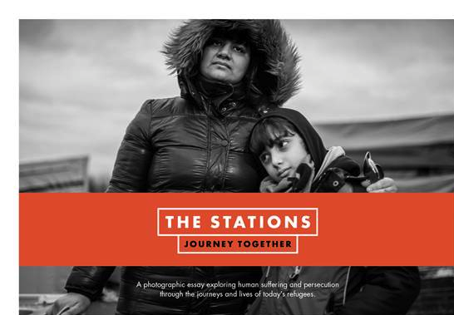
Tuesday 20th – Friday 23rd June 10am – 12 noon, 6pm – 8pm
Saturday 25th June 10am -1pm
Photographic Exhibition to mark Refugee Week
@ Wesley Methodist Church
The Stations of the Cross seen through the experience of refugees today
WWW.THESTATIONS.ORG.UK

