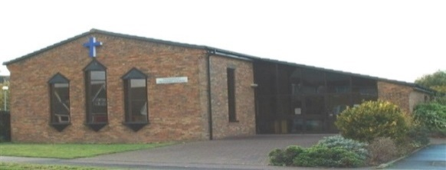

Thundersley Methodist Church

Afternoon Club Kennington Avenue, (near Tarpots Corner)

4th October, 2.30pm

Diagnosis and Effects of Dementia
A talk given by Michael Meehan of the Alzheimer’s Society

Come and find out more about Dementia, ask any questions you may have and discover services that are available in the area. Refreshments following.

